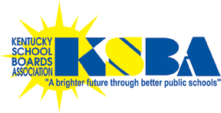
KSBA First Degree College Scholarship Program

One male, one female senior. $2,500 each. Good to any two-year, four-year college or university, in state or out. Non-renewable. Nominations of one male and/or one female student per public school district, selected by the school board.

Eligibility
Nominees must be:
- A high school senior intending to go to college;
- From an immediate family (parents, guardians, siblings) who has not earned a college degree;
- Have obtained an ACT reading score of at least 20 as a junior or senior.
The one-page application with ACT reading score, age, address and verification that there is no college graduate among immediate family must be signed by guidance counselor, board chairman and superintendent.
KSBA will pay the scholarship directly to students’ colleges of enrollment upon receipt of letter of college acceptance.
Timetable:

Letter/application form to board members, superintendents, high school principals and guidance counselors
from KSBA president: August 22, 2016

Boardcast “announcement” article: September 2016, reminders in October, early November

Article in Advocate: October; reminder in November edition

Application deadline: November 15, 2016 (received by KSBA)

Drawing: December 2, 2016 at KSBA Board of Directors meeting

Selectees’ notified: December 5, 2016 by KSBA President

Selectees’ acceptance: January 2, 2017 to executive director

Presentation: February 25, 2017 Annual Conference luncheon by KSBA president, sponsors

Payment: By June 1, 2017 ...
students must provide college letter of acceptance to executive director

(Over ... for First Degree College Scholarship Program application)
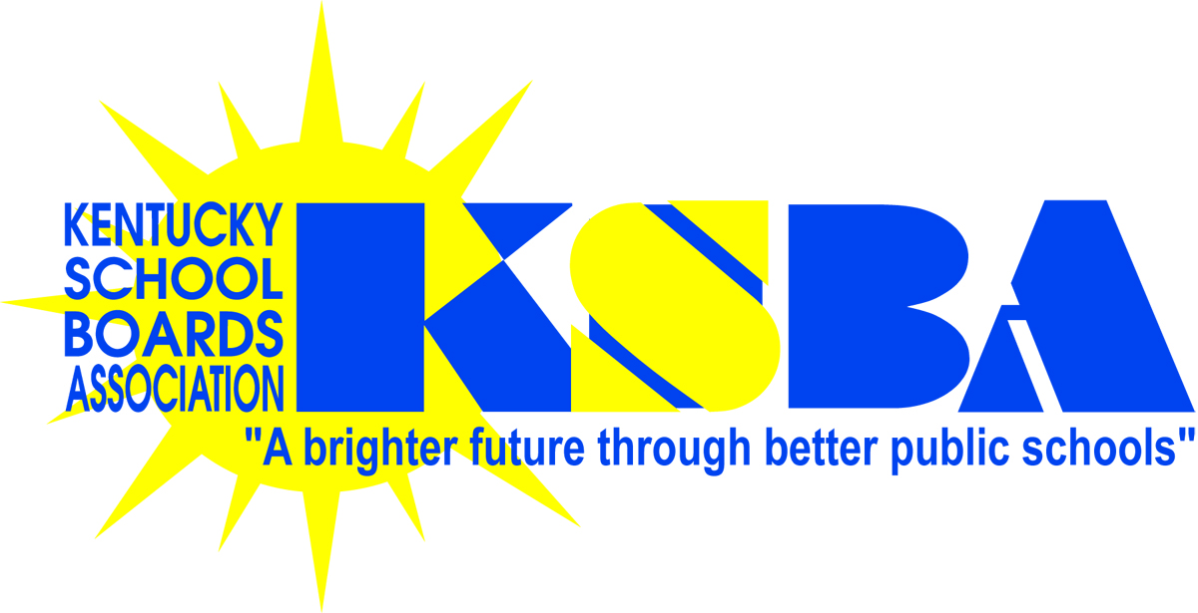
KSBA First Degree College Scholarship Program (application)

The board of directors of the Kentucky School Boards Association will fund two $2,500 scholarships for eligible Kentucky high school seniors to attend any two- or four-year accredited college or university, in state or out. One scholarship each will be awarded to a male and a female student. These nonrenewable scholarships will be paid directly to the institution of higher education upon the recipients’ official admission acceptances.

Eligible students are those who would be the first members of their immediate families (parents, guardians, siblings) to complete degree requirements from an institution of higher education. Eligibility must be affirmed and signed by the high school guidance counselor and the school district's board chairperson and superintendent.

Any Kentucky board of education may place in nomination the names of up to two students, one male, one female with a minimum ACT reading score of 20. KSBA will accept receipt of the first two eligible application forms per school district by the deadline noted below (additional forms will be disqualified). The scholarships will be awarded based on a drawing conducted by the KSBA Board of Directors at their December 2016 quarterly board meeting.

Application (nomination) form as certified by the high school guidance counselor

Student's Name: (please print)______________________________________ ____ Age ___Male ___Female

Home Mailing Address: ______________________________________________________________________________

Home Phone: ( )_________ Cell Phone: ( )__________ Email: __________________________

High School: _______________________ School District: _______________________ ACT Reading Score: _______

High School Guidance Counselor (Signature): ______________________________ Email: __________________________

We, the undersigned, hereby affirm the nomination of this student for the KSBA First Degree College Scholarship Program; that he/she is a senior in good standing at the high school; that the information included above is accurate; and that this student would be the first from his/her immediate family to earn a college degree. Chairman and superintendent may sign a maximum of two application forms per school district (one male and one female).

Signed:

Chairperson, local board of education PRINT NAME EMAIL

Superintendent, local board of education PRINT NAME EMAIL

Return completed form to Kathy Amburgey, KSBA, 260 Democrat Drive, Frankfort, KY 40601 (kathy.amburgey@ksba.org)
Applications must be received at the KSBA office no later than close of business November 15, 2016.
Revised 8.11.16

